Alexandra Wine Company
Davishon Pinot Noir 2015

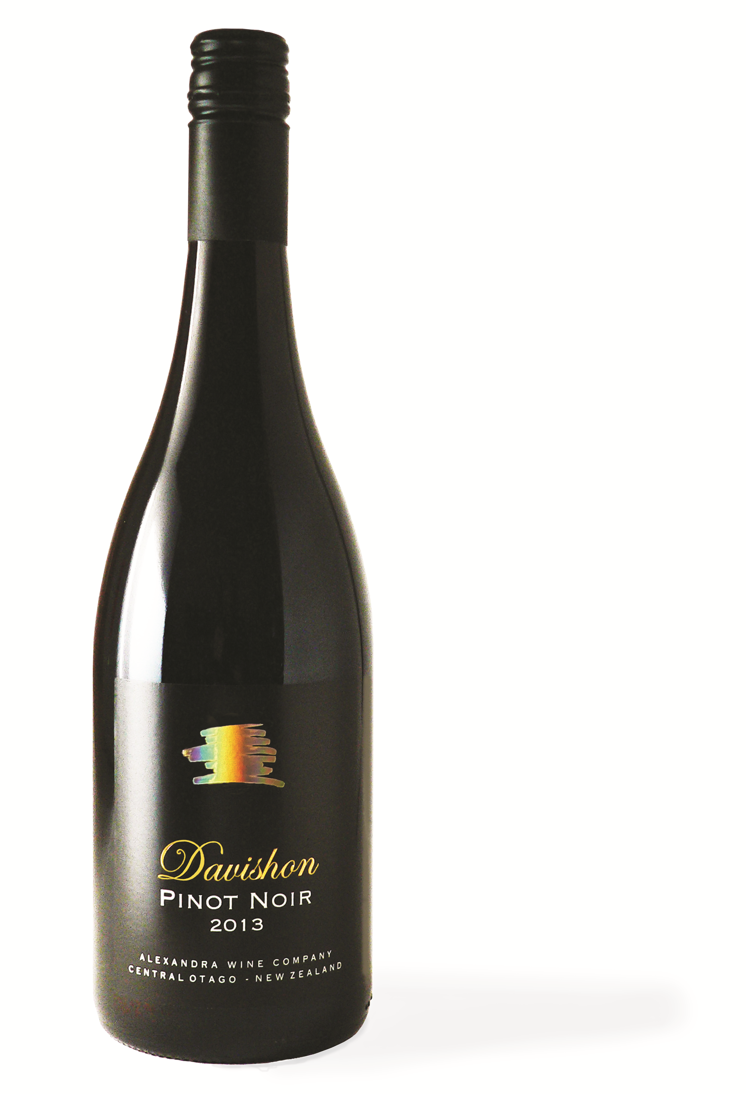

ALEXANDRA WINE COMPANY
The Davishon Vineyard is situated on the terrace above the Clutha River between Alexandra and Clyde in Central Otago. Grapes have been growing here for 130 years. Jean Desire Ferauds produced the first grapes in Central Otago here in the 1860’s. He could see that the hot summer days and relatively cool nights would produce world class wines. Soils are free draining river gravels and the summer/autumn rainfall is very low. The philosophy of viticulturist and winemaker is low volume/high quality “to produce the best Pinot Noir possible!”
The label shows a gold stylised Central Otago schist rock (made famous in scenes from the Lord of Rings) depicting the dry harsh environments and the history of gold in the valleys and mountains of the region.

WINEMAKING NOTES
Davishon Vineyard is trellised on a Geneva double curtain and spur pruned to 10 shoots per metre. It is extensively thinned to 6 tonnes per hectare and harvested by hand. Each clone of fruit was harvested separately and kept separate at all stages of vinification.
The fruit (clone 5 and 10/5) was harvested on 11-13 April 2015 and destemmed into tank, before being inoculated with selected wine yeasts to carry out the fermentation. The wine was aged in French Oak barriques for approximately 10 months, of which 25% was new oak. 50% were one year old(second fill) barrels.

WINE ANALYSIS
Brix 24
Alcohol 13.7%
pH 3.63
Total Acidity 5.67g/L
Harvest Date 11 & 13th April 2015
Bottling Date 24.03.16

TASTING NOTES
Deep purple with purple hues.
Fragrant violet, raspberry, dried herb, spice and leather.
Lovely sweet fruit entry showing ripe red and black cherry, plum, leather and a hint of vanilla. Medium bodied with excellent concentration and complexity. The tannins are very silky and they lead into a long red berry and mineral finish.

GOLD – Australian Boutique Wine Awards 2016

